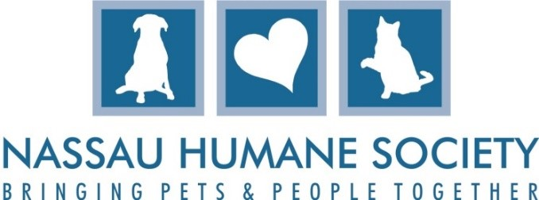
Veterinary Technician
Position Summary
Nassau Humane Society improves the lives of homeless animals in our community by providing them shelter and compassionate care. Our work focuses on adoption services, education about responsible pet ownership, and working to reduce animal overpopulation and homeless pets.
We are seeking a dedicated and compassionate Full-Time Veterinary Technician to join our team. This role involves a combination of surgical, medical and administrative duties to ensure the health and well-being of shelter animals. The ideal candidate will have surgical experience, in private practice or shelter, a strong attention to detail, excellent organizational skills, and a passion for providing humane care to animals in need. This is a full-time role, five days per week, reporting to Lead Veterinary Technician.
Responsibilities
- Prepare a list of animals scheduled for spay/neuter surgery by working with Lead Vet Tech for shelter animals, outside partners for community days, as well as taking bookings for low cost spay/neuter for members of the public.
- Working with Lead Vet Tech, make sure all animals scheduled are of weight and healthy for surgery.
- Prepare for surgery by preparing the mobile surgical clinic and making sure surgical packs and other supplies are ready for surgery.
- Work with Lead Vet Tech on supply needs by maintaining the inventory of surgical supplies and medicines for the mobile clinic.
- Assist the Surgeon with spay/neuter surgeries, mass removals and dental with surgical procedures, maintaining sterile conditions and sanitizing operating areas.
- Perform routine and surgical nursing care, monitoring anesthesia, administering injectable medications and vaccines as required, and monitoring patients post-operatively.
- Enter and update surgical paperwork and records in Pet Point and Clinic HQ.
- Respond to emergency situations and administer triage care, as needed.
- Administer vaccinations, blood draws, and parasite treatments.
- Perform routine care such as cleaning and dressing wounds, administering medications, implementing special diets, and collecting samples.
- Conduct daily health evaluations, intake exams, and vaccinations for shelter animals.
- Always maintains medical department procedures and protocols regarding humane care and treatment of animals.
- Other duties assigned by Lead Vet Tech.

Core Skills & Qualifications
- Certified Veterinarian Technician preferred
- Minimum of 1 year of surgical experience, ideally 2 preferred.
- Medication administration skills.
- Ability to work under pressure within a fast-paced and changing environment.
- Strong communications skills, both written and verbal.
- Excellent computer skills, with knowledge of Clinic HQ or other similar software preferred.
- Can follow instructions and a team player.
- Ability to stand for extended periods, lift to 50 lbs. and work in hot and cold temperatures.
- Valid driver’s license
- Reliable transport
- Veterinary Technician Experience in Surgery
- Animal catheterization
- Animal restraint
- Animal handling, including feral cats
- Veterinary terminology

The above statements are intended to describe the general nature and level of work being performed. They are not intended to be an exhaustive list of all duties, responsibilities, and skills. I have read and fully understand my job description.

________________________ _________________________
Employee Signature Date

________________________ _________________________
Adoption Center & Shelter Director Date

